2.35: a)
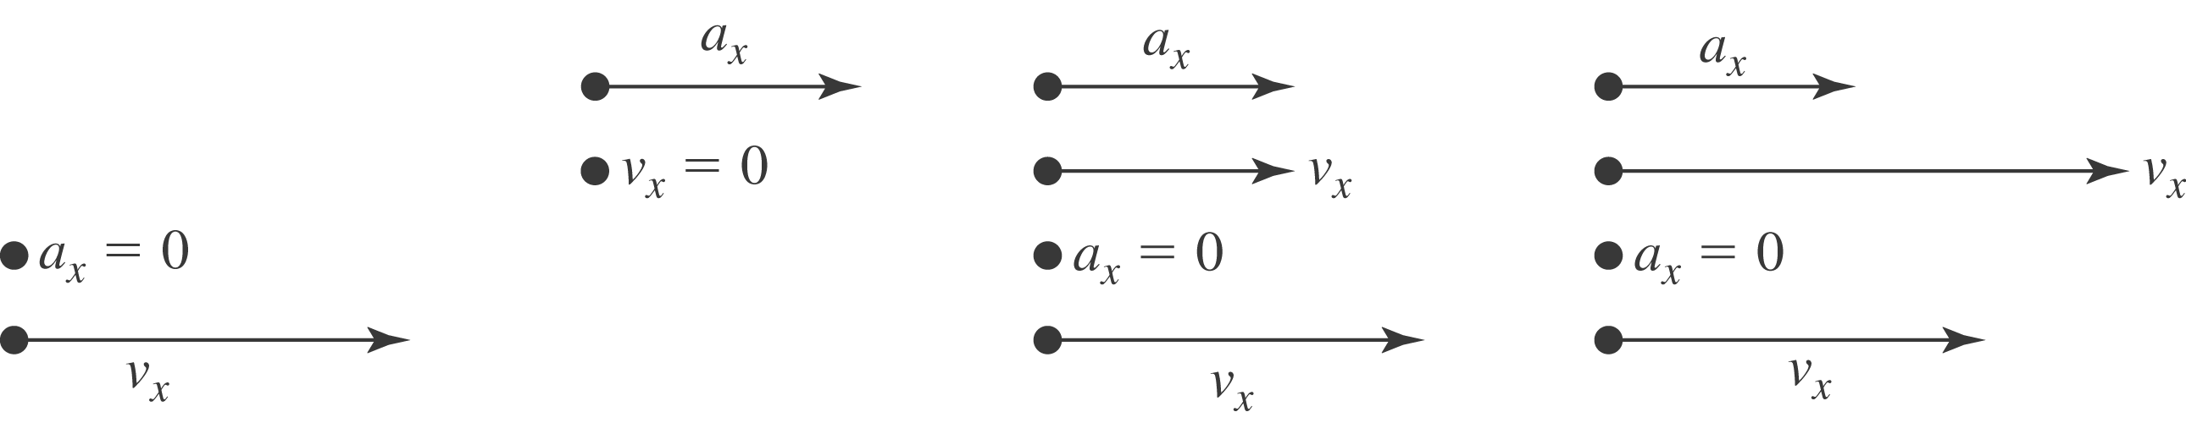

b) From the graph (Fig. (2.35)), the curves for A and B intersect at t = 1 s and t = 3 s.

c)
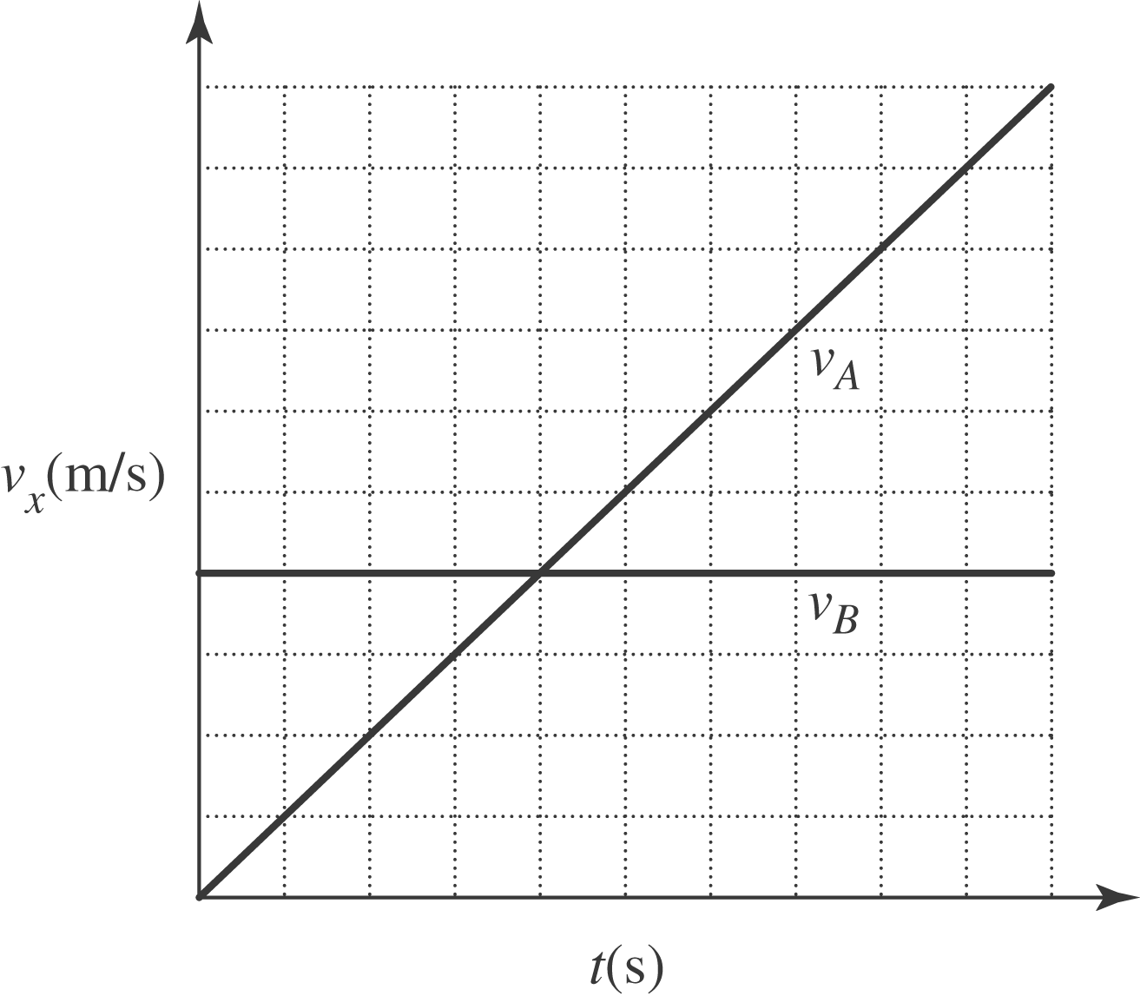

d) From Fig. (2.35), the graphs have the same slope at t = 2 s . e) Car A passes car B when they have the same position and the slope of curve A is greater than that of curve B in Fig. (2.30); this is at t = 3 s. f) Car B passes car A when they have the same position and the slope of curve B is greater than that of curve A; this is at t = 1 s.

